**Practical 5: Different controls in UiPath**

**a. Implement the attach window activity.**

Steps 1: Open UiPath Studio and click on Blank to start a fresh project. Give it a meaningful name. Like Pratical5A.

Steps 2: Open Main.xaml from Project tab. On the Designer panel, double click a Attached window activity from the Activities panel.

Steps 3: Open Notepad and click on Indicate window on screen from Attached window activity. And select blank notepad page.

Steps 4: Take another activity like Type Into activity and click on Indicate window on screen from type into activity. And type as per your requirement e.g. “welcome to sn College”.

Steps 5: It will show complete flow like below.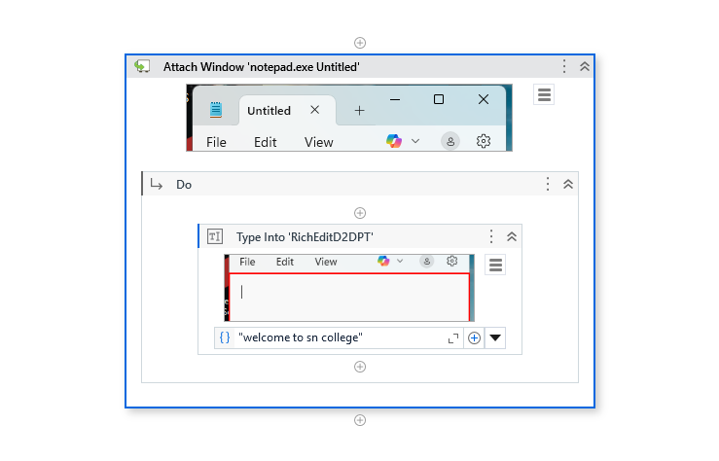

O/p:

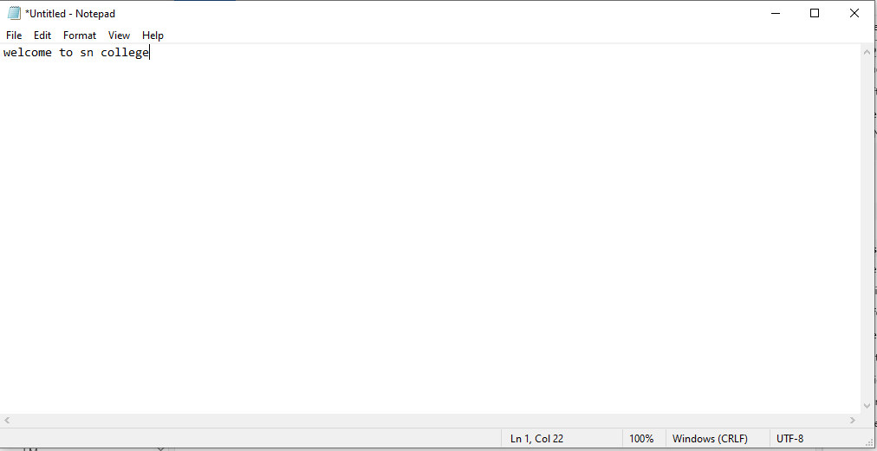

**b. Automate using Anchor Base.**

Steps 1: Open UiPath Studio and click on Blank to start a fresh project. Give it a meaningful name. Like Pratical5B.

Steps 2: Open Main.xaml from Project tab. On the Designer panel, double click **Anchor Base** activity from the Activities panel.

Steps 3: Select any label name from any form (Google form or any login form).

Steps 4: Select Anchor Position like top/bottom/left/right/auto.

Steps 5: Select **Type Into** activity from activity window. And select textbox which you want to fill.

Sample link:

<https://docs.google.com/forms/d/e/1FAIpQLSfBt4jcytSWD6_aH9j30SW8_qFF2U_4CjTB5ARUITJxqfstyg/viewform?usp=pp_url>

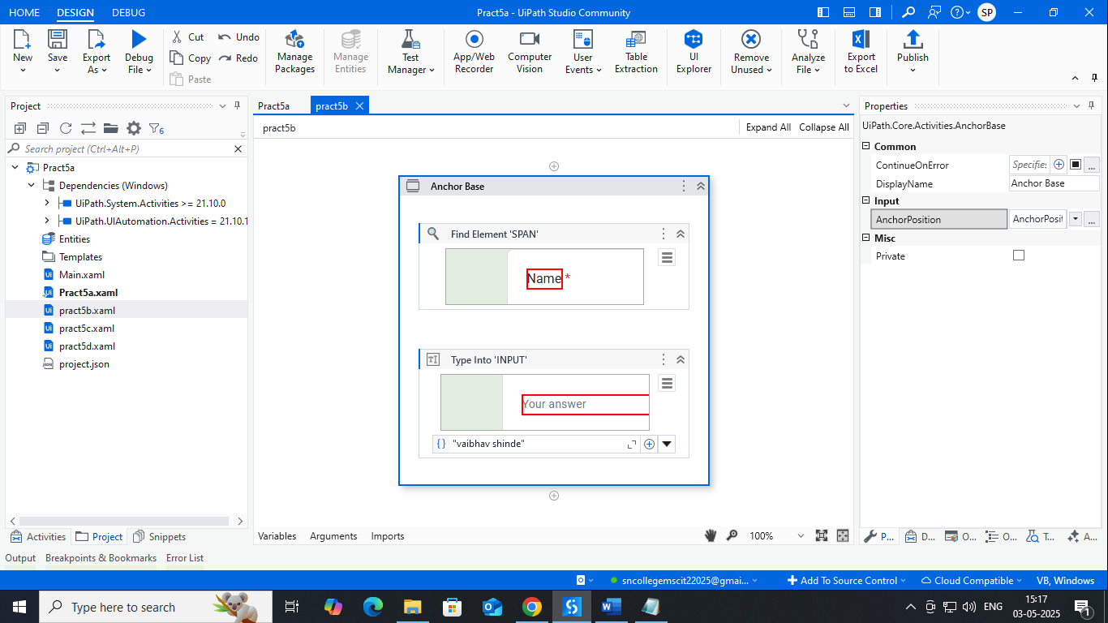

**O/P:**

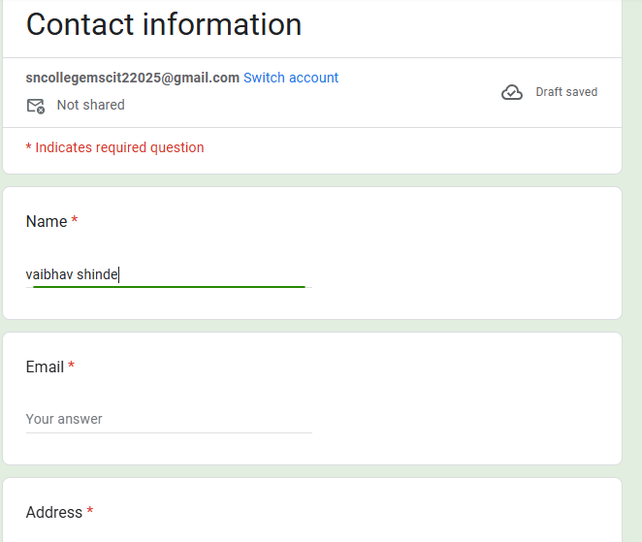

**c. Automate using Element Exists.**

Steps 1: Open UiPath Studio and click on Blank to start a fresh project. Give it a meaningful name. Like Pratical5B.

Steps 2: Open Main.xaml from Project tab. On the Designer panel, double click **Element Exists** activity from the Activities panel.

Steps 3: Click on Indicate window on screen and select **Google search** button from **google.com**.

Steps 4: Create one variable **nameexists** as **boolean**. And mapped in exists property of **Element Exists** activity**.**

Steps 5: Select **Else-if** activity from activity window. And give condition as below.

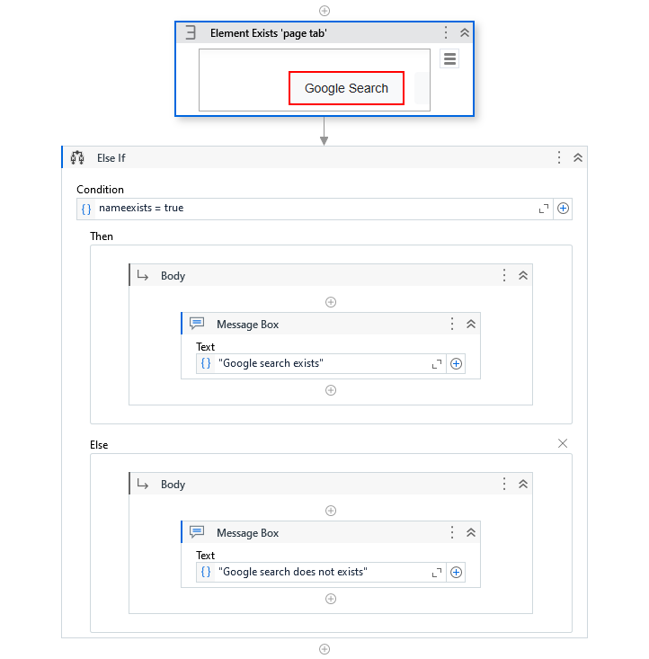

**O/p:**

|  |  |
| --- | --- |
| **For** [**https://www.google.com**](https://www.google.com) | **For https://www.google.com/imghp** |
|  |  |

**d. Automate using Find Children control.**